Design of Low Pass Filter using Windowing Techniques
4.2. Design and Analysis of an FIR Low-Pass Filter Using the Hamming Window Technique in MATLAB
Program (MATLAB Code)
clc;
clear;
close all;
%% --- Input Parameters ---
fp = 1000; % Passband cutoff (Hz)
fs = 4000; % Sampling frequency (Hz)
N = 50; % Filter order (even number preferred)
wc = fp/(fs/2); % Normalized cutoff frequency (0 to 1)
%% --- FIR Low Pass using Hamming Window ---
b_hamm = fir1(N, wc, 'low', hamming(N+1));
disp('--- Hamming Window Coefficients ---');
disp(b_hamm');
%% --- Plot Frequency Responses ---
figure;
freqz(b_hamm,1);
title('Low-pass FIR using Hamming Window');

Output
--- Hamming Window Coefficients ---
0.0010
0
-0.0013
0
0.0021
0
-0.0034
0
0.0055
0
-0.0084
0
0.0125
0
-0.0181
0
0.0260
0
-0.0379
0
0.0580
0
-0.1026
0
0.3168
0.4995
0.3168
0
-0.1026
0
0.0580
0
-0.0379
0
0.0260
0
-0.0181
0
0.0125
0
-0.0084
0
0.0055
0
-0.0034
0
0.0021
0
-0.0013
0
0.0010

Fig
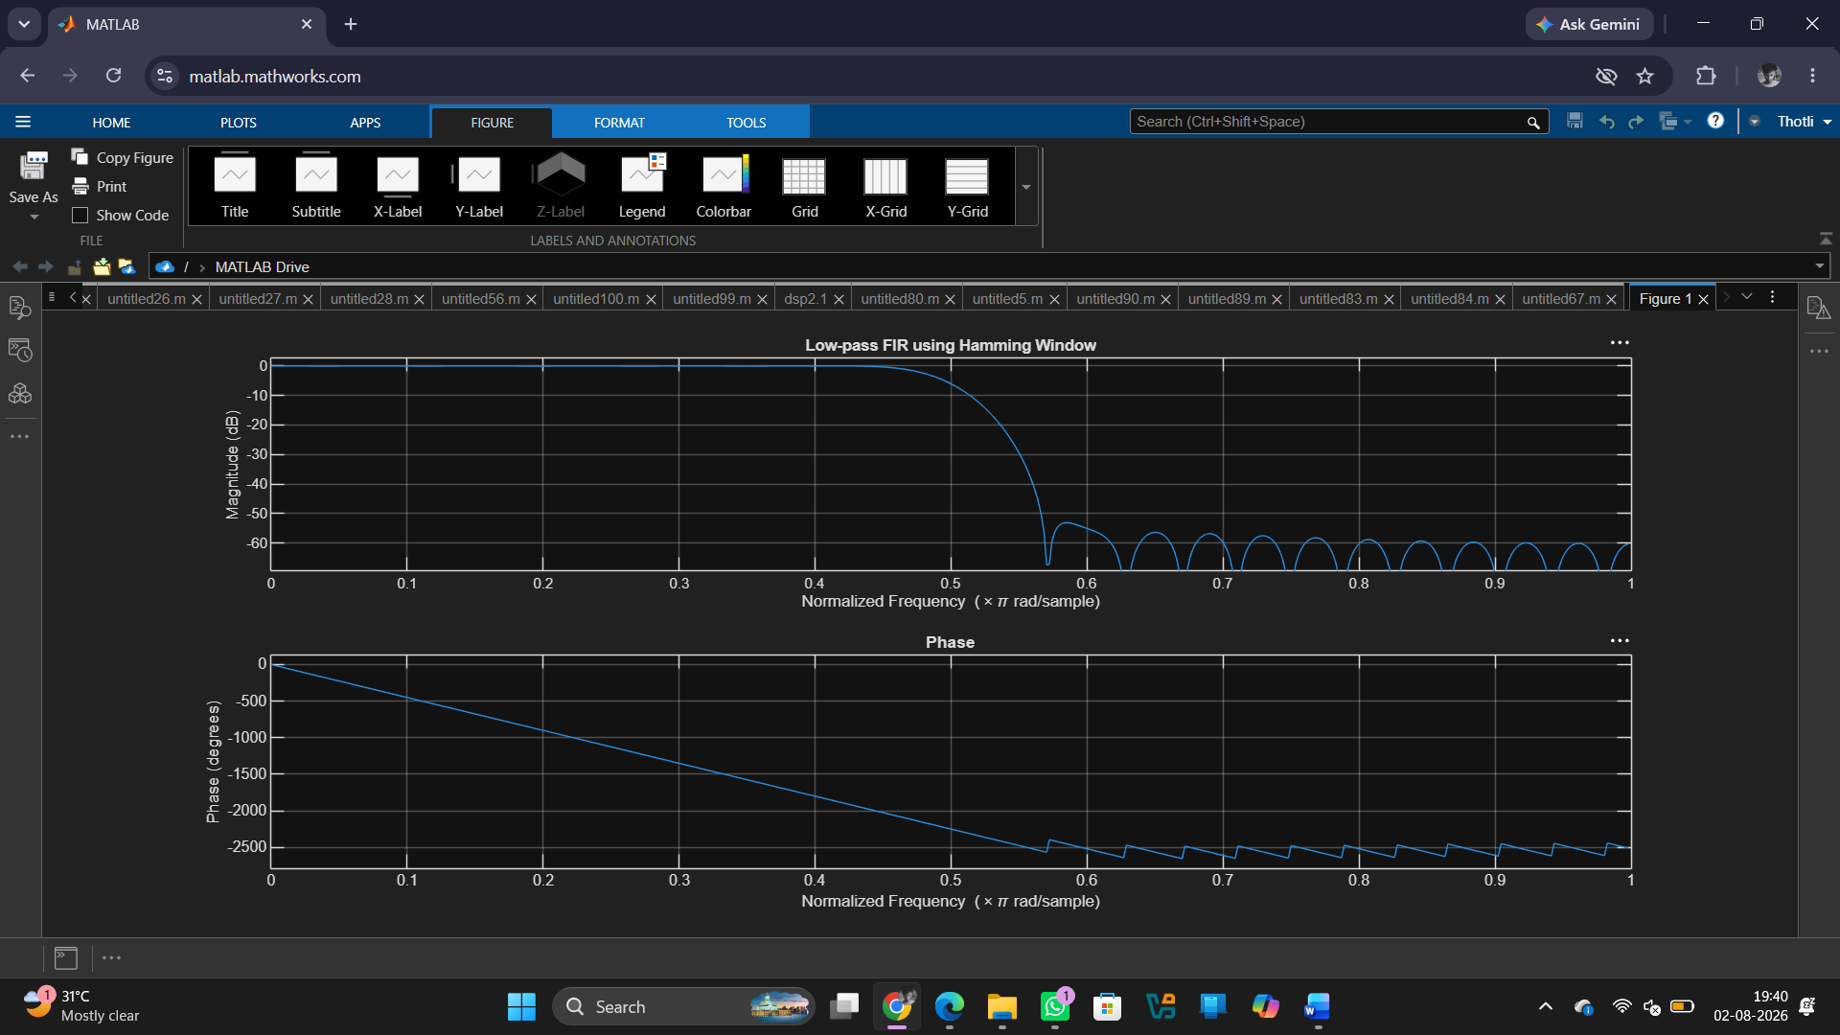

Result:
1. The FIR Low-Pass Filter was successfully designed using the Hamming Window technique for the specified filter parameters.
2. The FIR filter coefficients were generated and implemented successfully in MATLAB.
3. The magnitude and phase responses of the designed filter were obtained and analysed.
4. The filter exhibited the desired low-pass characteristics with improved stopband attenuation compared to the Rectangular Window method.

